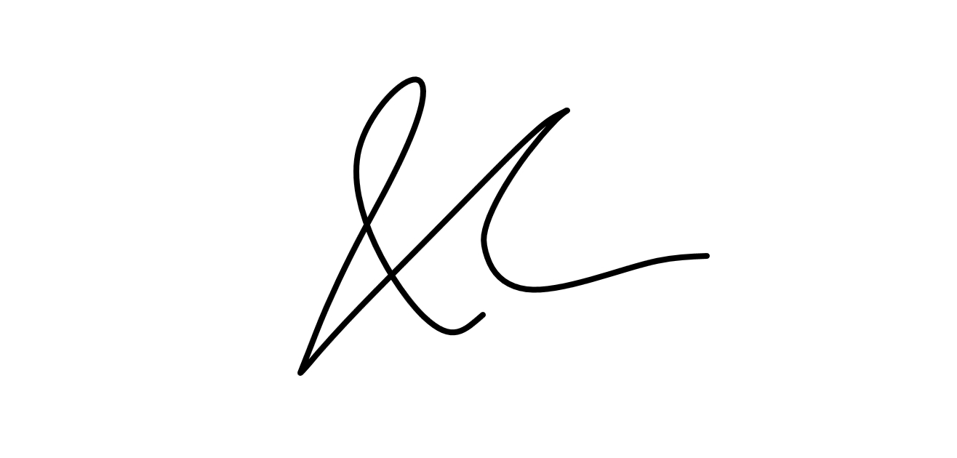
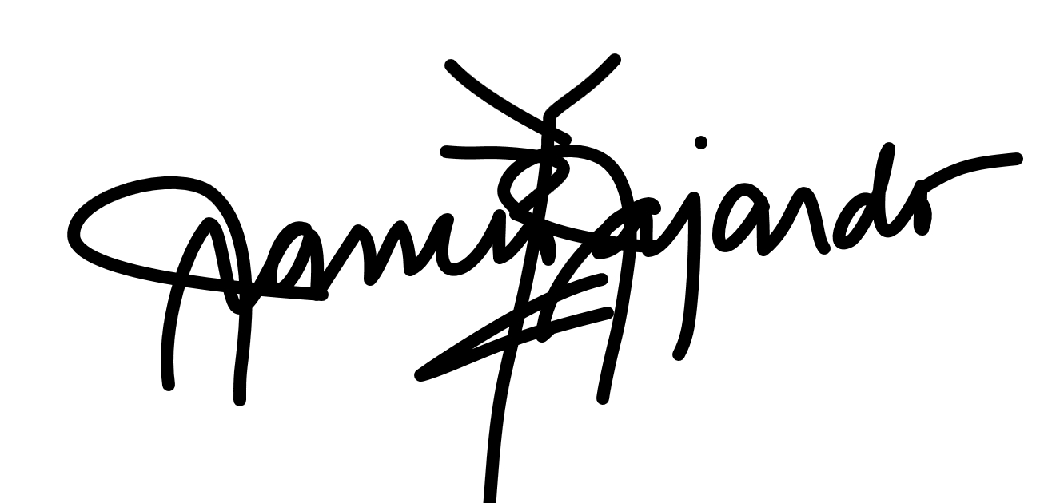
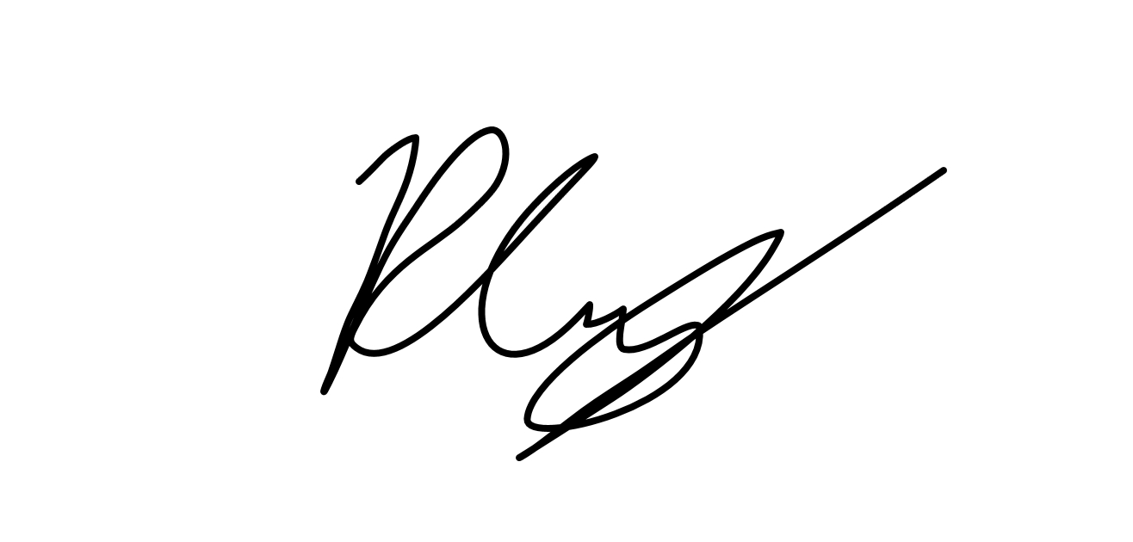

CERTIFICATE OF AUTHORSHIP

We hereby certify that this submission Double Tap Project Scope Document abides by the principles stipulated in the DISCS’ Academic Integrity Policy document. We further certify that we are the authors of this paper and that any assistance we received in its preparation is fully acknowledged and disclosed in the documentation. We have also cited all sources from which we obtained data, ideas, or words that are directly copied or paraphrased in this document. Sources are properly credited according to accepted standards for professional publication.

___________________ ___________________ ___________________
Aaron Basco Casurao Raymond J.N.C. Cruz Francis Gerard Fajardo

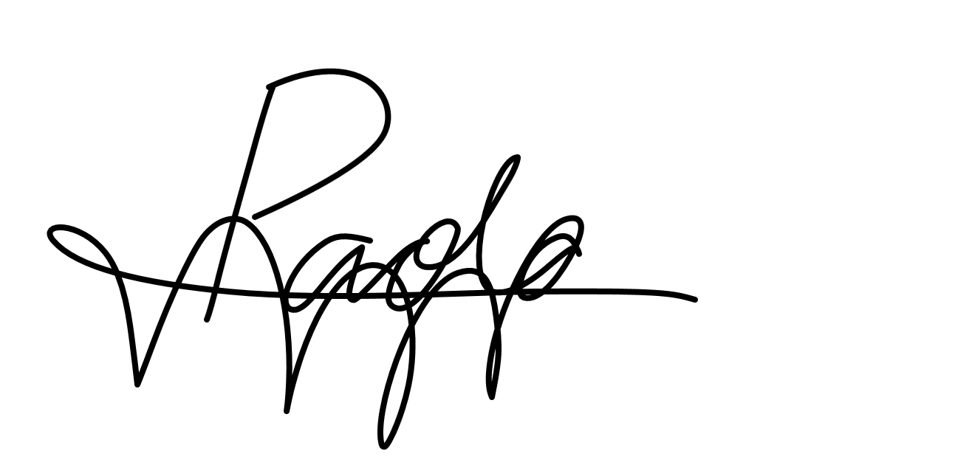
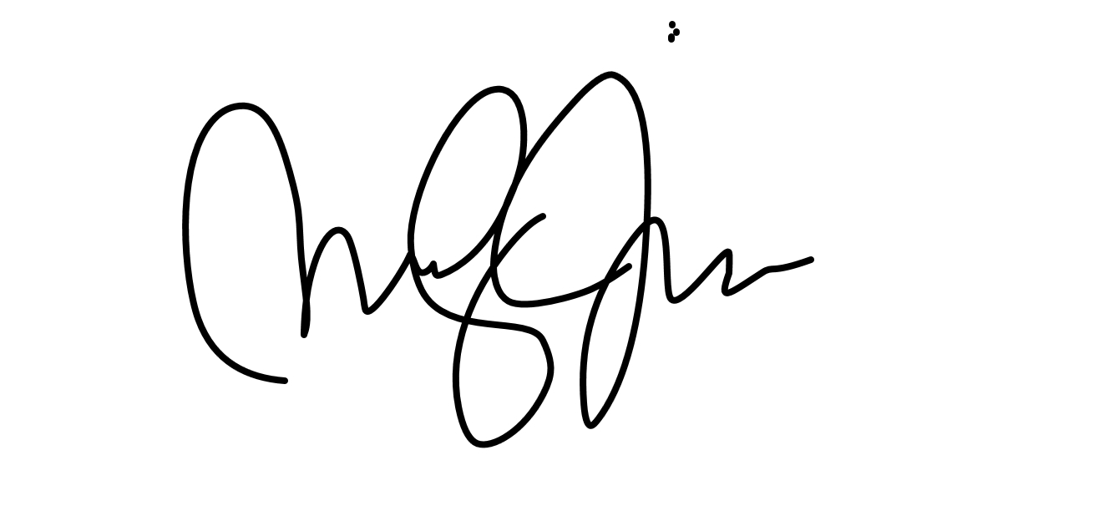
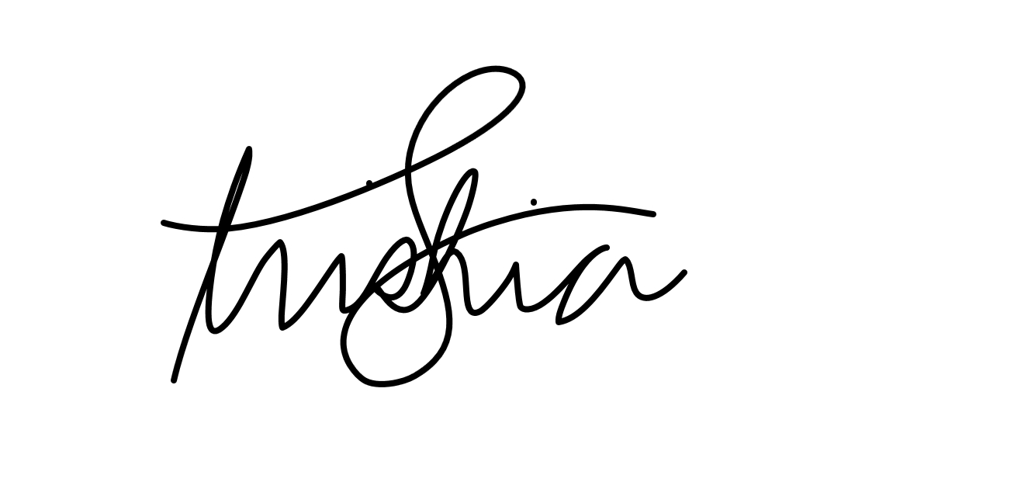

___________________ ___________________ ___________________
Trishia Gerobiese Celina Simone Enciso Jaldon Jan Paolo Luces

Submitted to: Joselito Olpoc
Date of Submission: 8/21/2013
As required in: MIS 141
Sources: Refer to document citations.

